Collaborative project on dismantling racism
Group 3
Unique get-together society.
Coast mountain college
ETHC 150-Business ethics winter 2021
Dave McKeever
March 28, 2021

Collaborative project on dismantling racism:

Quotes and poems:

Quotes by Abhijith:
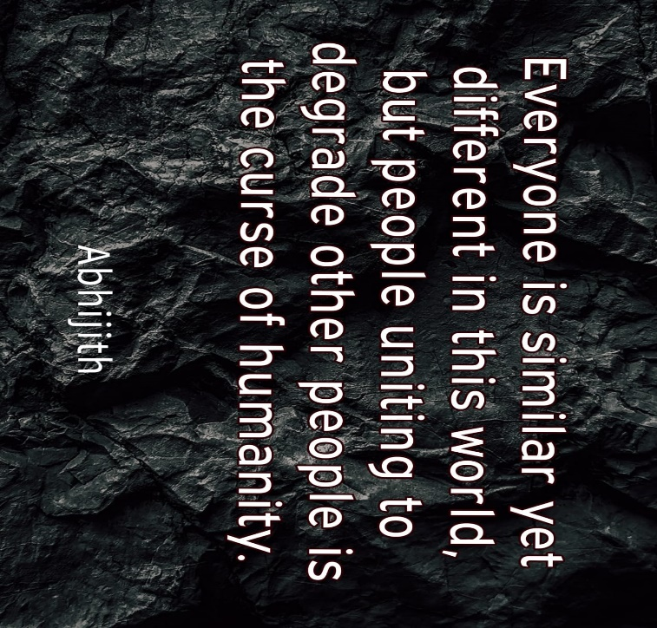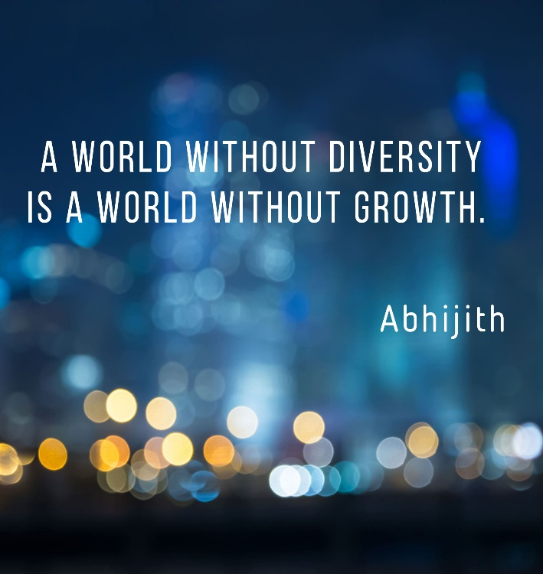
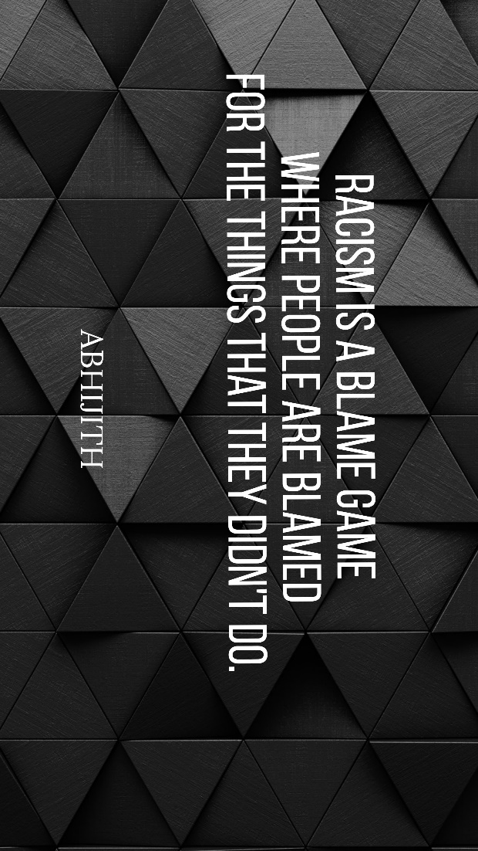
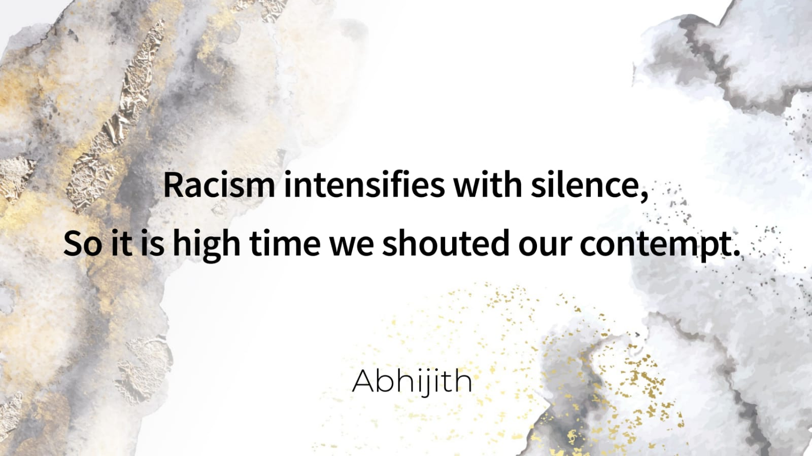

Explanation.
- Everyone is similar yet different in this world, but people uniting to degrade other people is the curse of humanity.
People often form a group so they can be stronger together which is a good thing, but when they get stronger, they tend to see others as weaker that will make it harder for people who are struggling to find a balance in life.
- A world without diversity is a world without growth.
The main obstacle behind the growth of a society is the things that make people divided. We can only achieve greatness when we are together. When people are racist, they always intentionally or unintentionally divide people.
- Racism is a blame game where people are blamed for the things that they did not do.
People have different traits according to their genes and evolutionary traits; a person cannot be blamed if he has black skin or if he is Asian. It is disheartening to know that people become mean to others just because they think they are low class. Personality and character are the things that we should value when we meet, people not otherwise.
- Racism intensifies with silence, so it is high time we shouted our contempt.
Racism is a big issue globally, and if we choose to be silent when we see racist attitudes in our society. It might affect the lives of the people around us, and we should always keep in our mind that we will also contribute to racism if we act against it.

Quotes by Aranpreet Kaur:
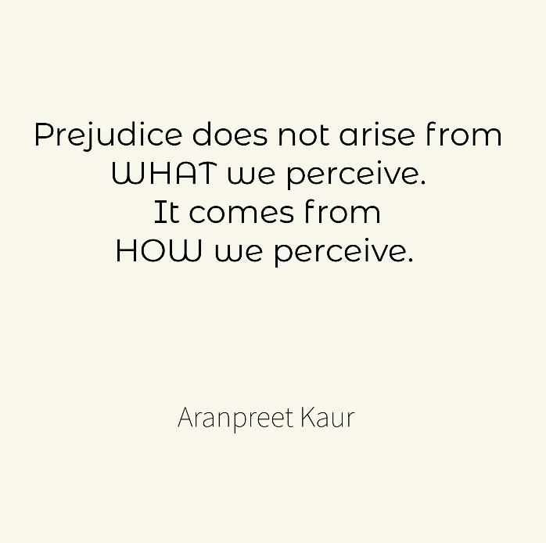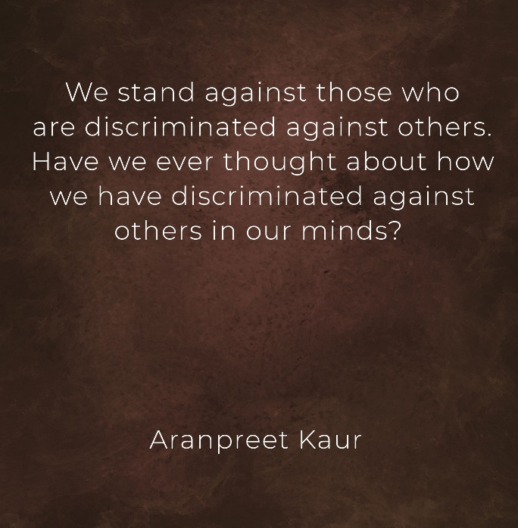
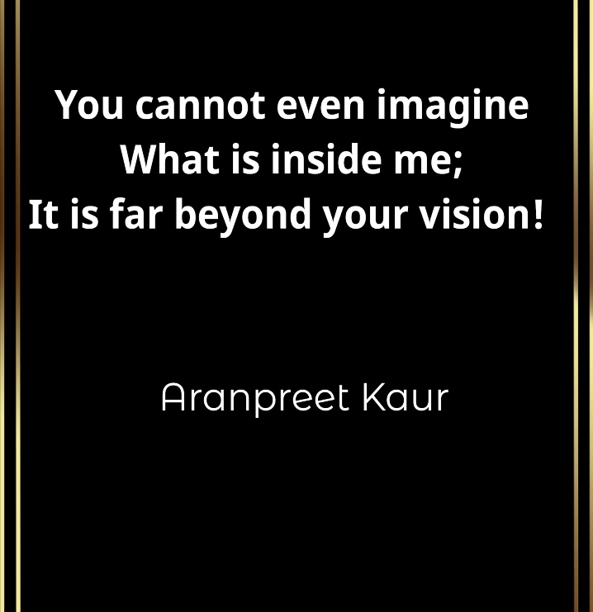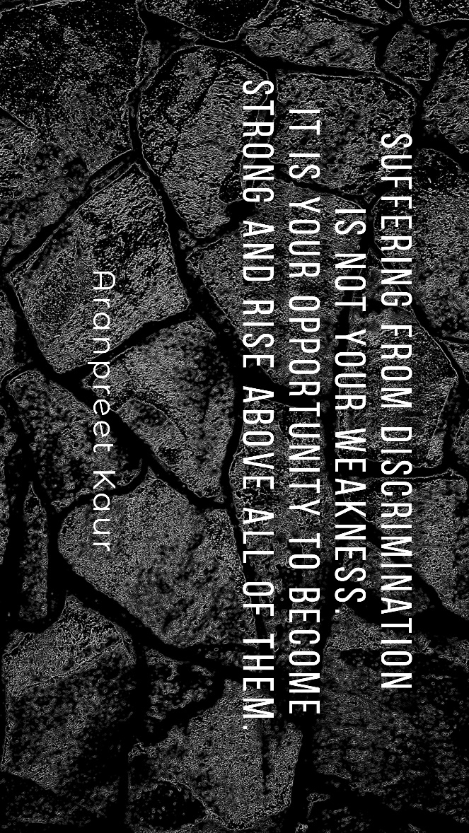

Explanation:
- Prejudice does not arise from WHAT we perceive. It comes from HOW we perceive.
Prejudice means to be the harm done to others by their judgment or actions that are against anyone's rights. In terms of judgments; prejudice comes when people do not focus on how they are considering their thoughts. For example, thinking about other culture and asking or gathering knowledge about is not bad at all. Though, comparing the cultures and not respecting the others cultures is prejudice.
- We stand against those who discriminate against others. Have we ever thought about how much we have discriminated against others in our minds?
We have seen many organizations and many people who stand against discrimination against others. They support them fully. However, all people intentionally or unintentionally discriminate against others. No one ever thinks over this point. If everyone would think about how they can be a reason for incrementing the discrimination, then there can be a chance that many people be trying to find their ways to combat discrimination against others.
- Expecting others to take a stand for you is your sin, not bearing the discrimination.
The people who are suffering discrimination should not expect others to stand for them and support them against those who discriminate. It is what makes cause discourage and make them weak. Instead, they should take their stand and make others realize that what they are doing is wrong.
- Suffering from discrimination is not your weakness. It is your opportunity to become strong and rise above all of them.
Bearing discrimination is difficult, though a person must not think that this will depress him/her. Rather, they must take it as an opportunity and show the world their capabilities while letting people realize that their way of treatment is against the human's basic law, that is, “respecting everyone and living together."
- You cannot even imagine what is inside me; it is far beyond your vision!
The people who are discriminated against others might say this to the world. The discriminators can never understand what them is inside and what capabilities they can convey to the world. Their talent is beyond the discriminator’s vision (imagination) as they are narrow-minded by orthodox stereotyping.

Poems by Aranpreet Kaur:
Title: Desire to fly!
- Traveling that heart what causes he wasn’t aware,
It isn’t beautiful but startles somewhere.
His longings then fallen asleep,
the need for freedom remains deep.
Cove cuts couldn’t even cringe the crook,
The dreadful brute had hung him on a hook.
Indeed, he sighed in pale,
Wished wore wings and flew with the gale.
[ NOTE: the usage of the informal word is in the poem just because to make a rhyme]

Explanation:
The poem is all about a person who has been discriminated against by others. He had tried to mingle up with people but, that experience was not beautiful, though it was surprising. By knowing what happens with people who are discriminated against by others, his wishes and desires vanished. The freedom to live like other human beings was collapsed for him. The discriminators (represented as 'crook' in the poem) knows what is happening with people who are discriminated against by others. They are aware of the things, but they do not show any support and sympathy to the people (represented as ‘cove’ in the poem) who are affected by such actions and judgments. Such discriminated individuals feel sad and gloomy with all such things, so, they are left with only their imaginations of living in a world where they are free as birds who can fly anywhere in the sky.
Title: Unheard voice.
- It is a melancholy that you would never like to envision,
Where days are in despondence, and nights stand for no desire or mission.
From the first day of the world, I wonder if I went on the wrong lane,
What sin I did that I am rewarded with the unconditional bane.
Have you ever pondered the way I used to feel?
Every day when you said, "Hey, come here, kneel!"
I tried to gather all my courage to stand against and scold you all,
Do you know how much I tried to do the same in front of the wall?
Wished you would know that your deeds are killing the insight of a soul,
Hundreds of pieces of my heart in the dark, just like coal.
Yet this crime is unseen by any government on the earth,
The world itself is unfair with full of rules of no worth.

Explanation:
In this poem, a person is thinking in his mind and reciting all his experiences in the form of the poem. Although he wishes to say it out loud to the world and know how much he has suffered that would melt their heart with sadness. Initially, he described that his story is melancholy, and nobody would ever like to think about it. It is because the days he spent had always been in despondence, and during nights when every other human being think about their dreams and desire, he has nothing. He is doubtful that he might have taken the wrong way or had done something wrong when he came to this world. He is trying to find the reason, why people are discriminating against him against others with hatred and pain. Then he added one of his experiences where he was being tortured by others and was forced to follow what they say. Every day he was ordered to kneel in front of them. He had tried many times to gather all his courage so to scold all those people who treated him badly, but he never was able to do so. He mentioned that he had been scolding them against the wall and practicing how he wanted to scold them all. He can only wish that discriminator would realize that what they are doing was killing him from inside into hundreds of pieces. After that, he is complaining that this is also a crime as it kills a person from inside yet no government (here in the poem means the one who has authority to control and rule the world) in world offenses. in his perspective, the world is full of rule and regulations, but all of the rules are worthless till every person counts same and equal with respect.

Infographics
Infographic made by Ashitha Mary Ben.
Content prepared by Palak Dhananjay Sali and Mandeep Kaur:
Link for infographic: https://create.piktochart.com/output/53481259-my-visual
Topic: discrimination at home

Types of Discrimination at Home
Academic Results:
It is when parents and guardians judge the worth of a child based on his or her academic results. When they compare results among siblings and constantly praise the child who is good at studies while condemning the one who is not. Some of the households place too much importance on academic achievements and put undue pressure on their children to achieve unrealistic targets. Parents have different opinions and approaches to encouraging their kids. While high expectations can be healthy, placing constant pressure on children can be harmful. When kids feel like each homework assignment will make or break their future or that each soccer game could determine if they get a college scholarship, that pressure can have negative consequences.
Family Expectations:
A household with a family history of high achievers in sports tends to have similar expectations from their children. Even we, as a society, tend to expect that the son of a legendary cricketer will be just as good as his father, or the son or daughter of an actor is going to be just as good (if not better) than their parent. Often, a child is forced to take music lessons, dancing lessons, join sports coaching classes just because their family is well known for their achievements in that field. Parents are often guilty of forcing their career choices on their children. The child of a doctor, engineer, or lawyer must follow their parent's footsteps and become one themselves. It is expected that once the child of a businessman grows up, they will join the family business.
Weight Issues:
If a child is obese, it can easily damage their self-esteem and perception of themselves. It is reinforced by behavioral changes in their parents, family members, and children at school. If a relative comes to visit and makes a comment on seeing the child (“you need to play outdoor sports, eat less and exercise more”) or a child starts name-calling at school ("fatty," "baby elephant," "hippo"), it can be devastating for the child. If a parent even jokingly becomes insensitive towards their child's weight, it can have serious repercussions on the child's mental health. Many parents tend to pay special attention to the child who is good-looking, or in good physical shape compared to a child who is "average" looking or obese. It sends a message to the child that physical attractiveness is what matters, and that they will only be accepted in the world if they are good-looking with a perfect body.
Discrimination Based on Age:
Many parents have a soft spot in their hearts for their firstborn or their youngest child. All children need to feel equally loved and cared for by their parents. Any preferential treatment by parents creates resentment amongst siblings. Children can also hold grudges against their parents for their preferential behavior for the rest of their lives, and it can become an extensive contributing factor for physical and mental health issues.
Disadvantages:
  - Higher levels of emotional and behavioral difficulties/ Later behavior problems
  - Higher rates of depression, anxiety, attempted suicide, cigarette dependence, illicit drug use, and episodic heavy drinking among adolescents.
  - Higher levels of aggression.
  - Higher incidence of Alzheimer’s disease later in life.
  - Problems in mind development.
  - Make children introvert.
  - Higher rates of mental illness.
  - Increased likelihood of cheating.
  - Refuse to participate.
  - Self-esteem problems.

Remedies:
- Never label your child “bad” and give up on her/him.
- Reach out for help to figure out why she/he is bad.
- Show her/him how to succeed.
- Stop comparing your child with others.
- Show your child that the joy of "doing" – which is much more than the happiness of "winning".
- Help your child to learn persistence.
- Reach out for expert help to find a strategy to help your child improve academic performance.
- Display unconditional love.
- Show your child that you love her/him unconditionally.
- Stop focusing on marks. Focus on learning.
- Do not make your child’s marks a topic you use to brag about to your friends.
- Understand and explain the true meaning of exams.
- Assure your child that teachers are not out to fail us.
- Help your child with goal setting.
- Help your child to stick to the schedule and finish everyday work.
- Talk to your child.
- Allow your child to do some household chores.
- Help your child to multitask right.
- Help your child to deal with distractions.
- Do not isolate your child from friends.
- Do not compare.
- Encourage your child to be nice to others.
- Adopt a Growth Mindset.
- Make expectations clear, realistic, and reasonable.
- Aim for personal bests and fulfilled potential.
- Let them make mistakes.
- Offer support and encouragement through the process.
- Erase the all-or-nothing attitude.

Animated video:
Link to the video: https://e.powtoon.com/pub/cc?_ri_=X0Gzc2X%3DAQpglLjHJlTQGlPzdJbJHMHGSsHPisBICzadcj5A7g94aW5wDsJ1JbEHjLHiUC3nVXtpKX%3DSSTTT&_ei_=Eq2tf9zs59idfPO1Sc_9BbkYhvnwsG3umZromQx24WbUkz1eDoN78VnQBw6WzrMJkdrU1leqW6zXC1xu5JY16veCsELj6Su-gcxcyBDVtQHysW5fHBG-CttBg7i37zy6oHabwJY4K0ZKSJv19nviMoQQmJ4Nnq2262DEJab7bQ7eqhotlMCRTvrS-jS8e4836LV46-rqF5v-adMFcXdkutoGv5uFmM.&_di_=7focou9o0gho5jatk6taerjdu8dlrlq8cnhratlvjufbkped3sm0
Content prepared by Palak Dhananjay Sali and Mandeep Kaur.
Video made by Nirankar Singh.
Topic: Discrimination in Student life and college life
Types of discrimination faced by students:
- disability
- gender reassignment
- race
- religion or belief
- sexual orientation
- LGBTQ Community
- Class (Especially Poor Class)
- Black students
Disadvantages or the impacts of discrimination on students:
- Homesickness
- Lack of self-esteem
- Mental health issues
- Poor sleeping habits
- Peer pressure
- Bullying
- Fear and Anxiety
Remedies or how to cope with this discrimination:
- Take care of your health and body.
- Stay Positive.
- Seek official help.
- Strengthen your beliefs.
- Never lose Faith in Goodness.

References:
- Dutta, D., 2019. Academic Pressure: 15 Ways To Manage Pressure Of Studies In Students. [online] What Parents Ask. Available at: <https://whatparentsask.com/academic-pressure-15-ways-to-manage-pressure-of-studies-in-students/> [Accessed 28 March 2021].
- 5 Ways to Set ‘High Expectations’ Without ‘High Pressure’. 2021. Melbourne Child Psychology & School Psychology Services, Port Melbourne. [online] Available at: <https://www.melbournechildpsychology.com.au/blog/5-ways-to-set-high-expectations-without-high-pressure/> [Accessed 28 March 2021].
- Hiapphere.com. n.d. Posters: Story Editor template design post 1.4.9.3 [Unlocked]. [online] Available at: <https://www.hiapphere.com/app/com.kvadgroup.posters> [Accessed 29 March 2021].
- https://www.apa.org. 2010. Children, Youth, Families and Socioeconomic Status. [online] Available at: <https://www.apa.org/pi/ses/resources/publications/children-families> [Accessed 29 March 2021].
- Nazareth, F., n.d. Challenges & Problems College Students Face - How To Overcome Them?. [online] AlignThoughts. Available at: <https://alignthoughts.com/challenges-and-problems-college-students-face/> [Accessed 28 March 2021].
- Piktochart. 2021. Create Infographics, Presentations & Reports | Piktochart. [online] Available at: <https://piktochart.com/> [Accessed 29 March 2021].
- Powtoon.com. n.d. Video Maker | Make Videos and Animations Online | Powtoon. [online] Available at: <https://www.powtoon.com/homepage/?utm_source=bing&utm_medium=cpc&utm_campaign=07_2020_brand&pa_id=erSJ4UHQwCA&ad_id=&ad_group_id=1332608681887682&keyword=powtoon&msclkid=c9e2c05e383a12ae7d4ca03f6e141406> [Accessed 29 March 2021].

